EfficientNet Pretrained Model
Efficientnet
EfficientNet is a family of convolutional neural networks designed to achieve high accuracy with much better computational efficiency than previous models. Its core innovation is the compound scaling method, which simultaneously scales a model's depth (number of layers), width (number of channels), and input image resolution using a consistent ratio, rather than just scaling one dimension at a time
It was introduced by Mingxing Tan and Quoc V. Le from Google Research in their 2019 paper "EfficientNet: Rethinking Model Scaling for Convolutional Neural Networks." The core idea behind EfficientNet is a new scaling method that uniformly scales all dimensions of depth, width, and resolution using a compound coefficient.

The EfficientNet-B0 Architecture Overview
EfficientNet-B0 serves as the baseline model, discovered using Neural Architecture Search (NAS) to optimize for both accuracy and efficiency (FLOPS)
. Its structure can be broken down into three main parts: Stem, Body, and Head
EfficientNet-B0 Architecture in Details
EfficientNet uses a technique called compound coefficient to scale up models in a simple but effective manner. Instead of randomly scaling up width, depth, or resolution, compound scaling uniformly scales each dimension with a certain fixed set of scaling coefficients. Using this scaling method and AutoML, the authors of EfficientNet developed seven models (show why body is 7layers) of various dimensions, which surpassed the state-of-the-art accuracy of most convolutional neural networks, and with much better efficiency.
The EfficientNet-B0 network consists of:
- Stem
  - Initial layer with a standard convolution followed by a batch normalization and a ReLU6 activation.
  - Convolution with 32 filters, kernel size 3x3, stride 2. -> this show why channels is 32 and output resolution for the next layer is (224/2=112)
- Body
  - Consists of a series of Mobile Inverted Bottleneck Convolution (MBConv) blocks with different configurations.
    - Each block includes depthwise separable convolutions and squeeze-and-excitation layers.
  - Example configuration for MBConv block:
    - Expansion ratio: The factor by which the input channels are expanded.
    - Kernel size: Size of the convolutional filter.
    - Stride: The stride length for convolution.
    - SE ratio: Ratio for squeeze-and-excitation.
abstraction of MBCONV
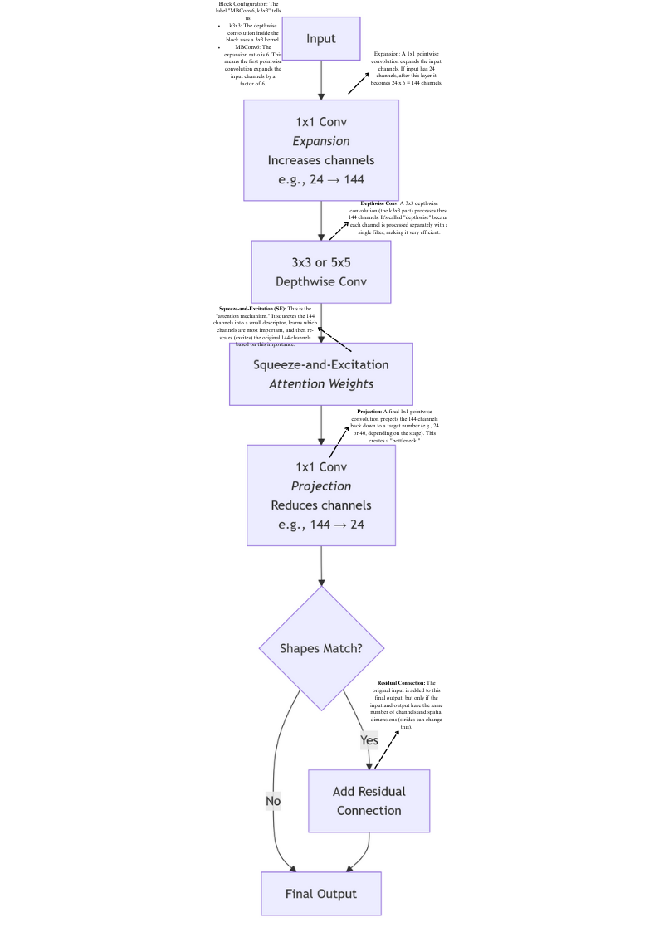
- Head
  - Includes a final convolutional block, followed by a global average pooling layer.
  - A fully connected layer with a softmax activation function for classification.
📊 Stage-by-Stage Architecture Table
The table below outlines the key stages of the EfficientNet-B0 model.
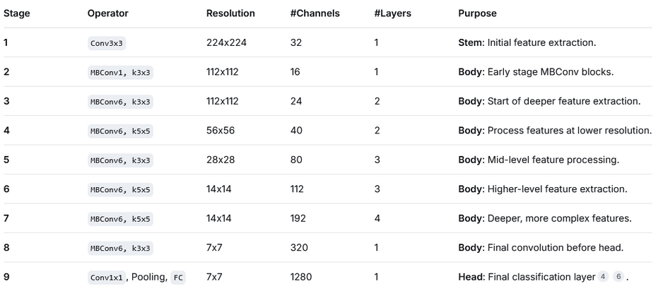

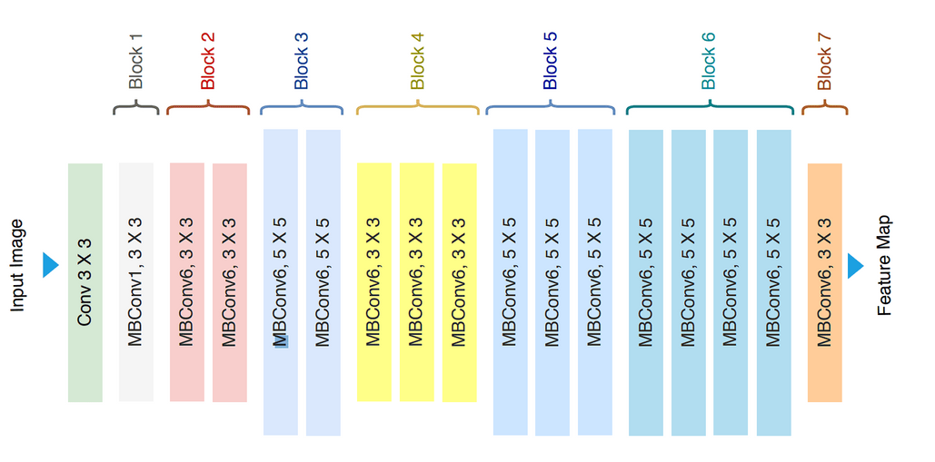

Compound Scaling Method
At the heart of EfficientNet lies a revolutionary compound scaling method, which orchestrates the simultaneous adjustment of network width, depth, and resolution using a set of fixed scaling coefficients. This approach ensures that the model adapts seamlessly to varying computational constraints while preserving its performance across different scales and tasks.
Compound Scaling: → (The Guiding Principle)
The authors thoroughly investigated the effects that every scaling strategy has on the effectiveness and performance of the model before creating the compound scaling method. They came to the conclusion that, although scaling a single dimension can help improve model performance, the best way to increase model performance overall is to balance the scale in all three dimensions (width(channels), depth(Layers), and image resolution) while taking the changeable available resources into consideration.
The below images show the different methods of scaling:
- Baseline: The original network without scaling.
- Width Scaling: Increasing the number of channels in each layer.
Scaling Network Depth (#Layers): It increases the number of times the MBConv block is repeated in each stage. For example, if B0's stage 5 uses an MBConv block 3 times, a scaled-up version like B4 might use it 5 or 6 times in the same stage.
- Depth Scaling: Increasing the number of layers.
Scaling Network Width (#Channels): It increases the number of filters in all convolutional layers (including the ones inside every MBConv block) across the entire network. This is what the #Channels column in your table changes for each stage.
- Resolution Scaling: Increasing the input image resolution.
Scaling Input Resolution: It simply increases the size of the input image fed to the network (e.g., from 224x224 in B0 to 380x380 in B4)
- Compound Scaling: Simultaneously increasing width, depth, and resolution according to the compound scaling formula.
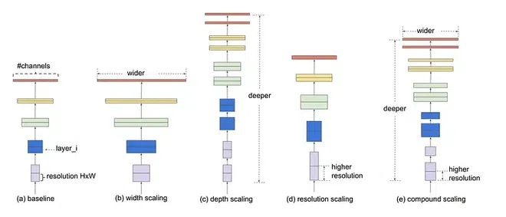
his is achieved by uniformly scaling each dimension with a compound coefficient φ. The formula for scaling is:
Width × Depth2 × Resolution2 ≈ Constant
The principle behind the compound scaling approach is to scale with a constant ratio in order to balance the width, depth, and resolution parameters.
The key is that these scaled parameters (depth repeats, channel counts) are set before training begins. During the forward pass, each MBConv block simply executes its fixed sequence of operations using its pre-defined, scaled number of channels.

how they work together inside an MBConv block
This is the fundamental operation that replaces standard convolutions. Let's compare them directly:
Standard Convolution does everything at once:
- Takes an input with C_in channels (e.g., 32)
- Applies C_out filters (e.g., 64 filters)
- Each filter processes all input channels simultaneously
- High cost: 32×64 = 2,048 channel interactions per spatial position

Depth-wise Separable Convolution
EfficientNet uses depth-wise separable convolutions to lower computational complexity without sacrificing representational capability. This is achieved by splitting the normal convolution into two parts:
- Depth-wise Convolution: Applies a single filter to each input channel.
Step 1 (Depthwise): 32 filters × 1 channel each = 32 operations
- Point-wise Convolution: Aggregates features from different channels.
Step 2 (Pointwise): 64 filters × 32 channels = 2,048 operations
- Total: ~2,080 operations vs. 2,048 in standard convolution? Wait, that seems wrong...
Actually, the real savings come from considering spatial dimensions too! Here's the proper formula:
For a K×K kernel, input C_in channels, output C_out channels, and feature map size H×W:
Standard convolution cost: H × W × C_in × C_out × K × K
Depthwise separable cost: H × W × (C_in × K × K + C_in × C_out)
Example with numbers:
For 3×3 kernel, H=112, W=112, C_in=32, C_out=64:
Standard: 112×112 × 32×64 × 3×3 = 112×112 × 18432 = 230M operations
Depthwise separable: 112×112 × (32×3×3 + 32×64) = 112×112 × (288 + 2048) = 29M operations
Savings: 230M vs 29M = ~8× fewer operations!

This makes the network more efficient by requiring fewer computations and parameters.

Variants of EfficientNet Model:
EfficientNet offers several variants, denoted by scaling coefficients like B0, B1, B2, etc. These variants differ in depth, width, and resolution based on the compound scaling approach. For example:
- EfficientNet-B0: The baseline model with moderate depth, width, and resolution.
- EfficientNet-B1 to B7: Successively larger variants achieved by increasing the compound scaling coefficient φ.
- EfficientNet-Lite: Lightweight variants designed for mobile and edge devices, achieving a good balance between performance and efficiency.
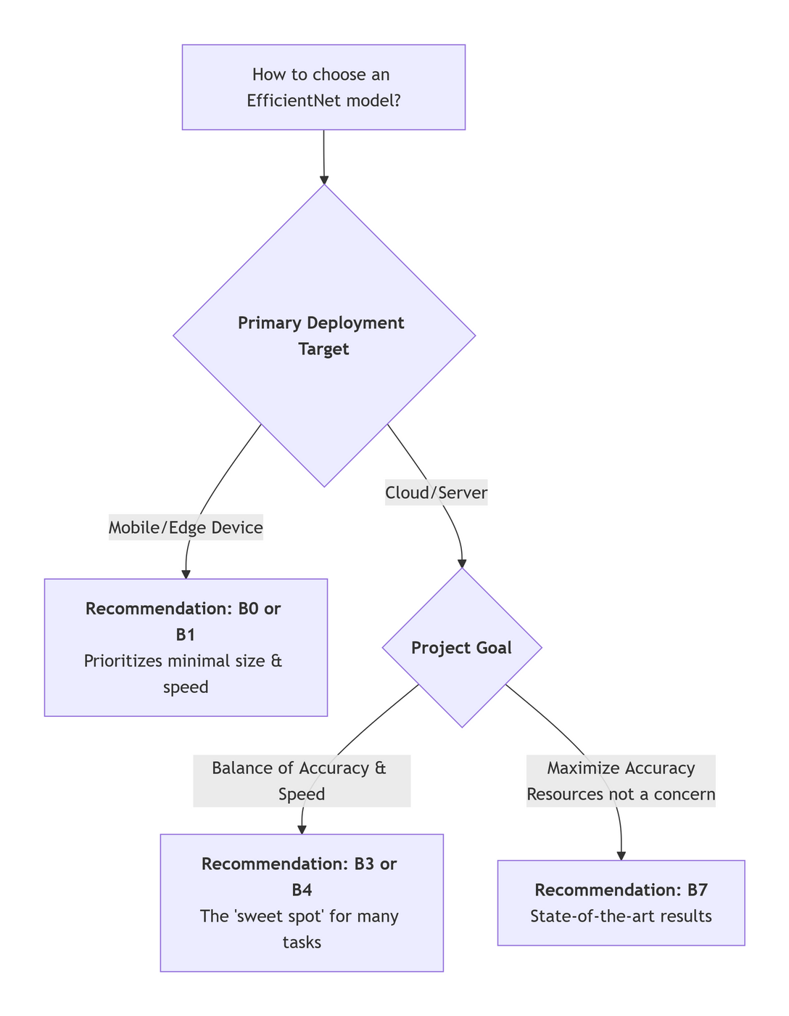
Each variant of EfficientNet offers a trade-off between model size, computational cost, and performance, catering to various deployment scenarios and resource constraints.

References
- Efficientnet Architecture - GeeksforGeeks(MOST RECOMMENDED TO LEARN AS BEGINING )
- EfficientNet Explained: Compound Scaling and Neural Architecture Search (MOST RECOMMENDED TO LEARN IN DETAILS)
- EfficientNet: Boost CNN Accuracy with Less Compute (the best for images explaination)
- EfficientNet: Smarter, Not Just Bigger, Neural Networks( Low-Level Explaination)
- Chat DeepSeek (Search) as Helper

